4.9 ANSWERS TO EXERCISES

4.9 Exercise 1

1. a) b)
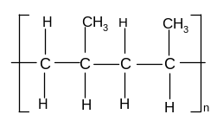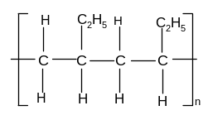
c) d)
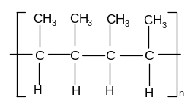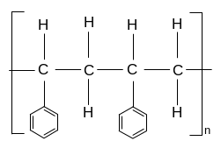

2. a) poly(2,3-dimethylbut-2-ene)
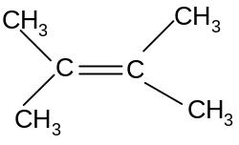

b) poly(1-chloropropene)
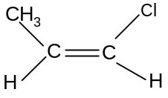

c) poly(1,1-dichloroethene)
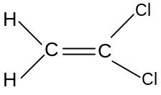

4.9 Exercise 2

1. a)
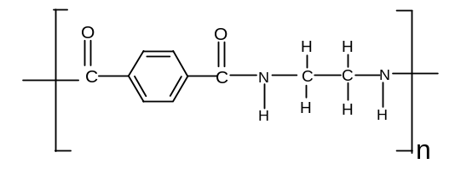
b)
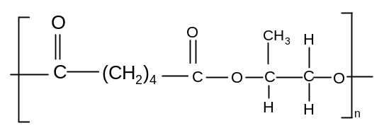

c)
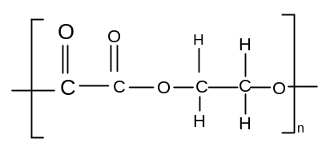

2. a) benzene-1,4-diacyl dichloride and ethan-1,2-diol
b) hexanediacyl dichloride and 1,6-diaminohexane
c) benzene-1,3-dicarboxylic acid and propan-1,2-diol
d) ethanediacyl dichloride and 1,2-diaminoethane

3. a) Condensation polymers are biodegradable, but addition polymers are not.
b) Condensation polymers have a shorter lifetime than addition polymers, but
can be much more easily recycled as they can be broken down into their monomers quite easily.

